**OS LAB 2**

*SIDDHARTH SHENOY*

*PES2201800499*

**EXERCISE 1:**

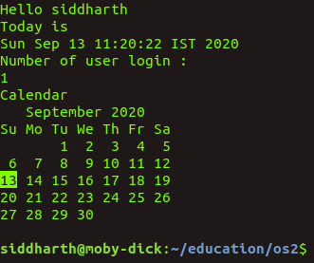

Why is statement exit 0 used?

Return code 0 means that everything executed successfully without any errors. Exit makes the script stop at that particular point and then returns to the command line.

What is the meaning of $ ?

$ shows the contents of the variable. Prefixing a variable name with $ indicates the value the variable holds.

**EXERCISE 2:**

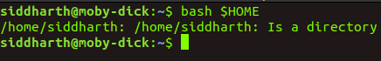

**EXERCISE 3:**

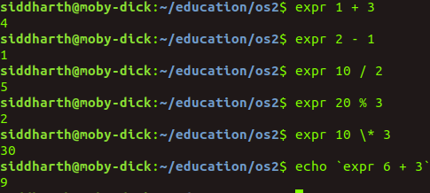

**EXERCISE 4**:

Single quote (‘) :

Preserves all the special characters within the string.

Double quote (“) :

Preserves most of the special characters within the string

(**for example**

#!/bin/sh

MYVAR=sometext

echo "double quotes gives you $MYVAR"

echo 'single quotes gives you $MYVAR'

**Output**

double quotes gives you sometext

single quotes gives you $MYVAR

**)**

Back quote (`) :

makes available the output of commands for assignment to a variable.

**EXERCISE 5:**

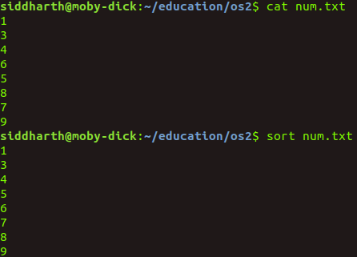

**EXERCISE 6:**

